XAI-TOMATO: A GRAD-CAM GUIDED CNN FOR INTERPRETABLE PLANT DISEASE CLASSIFICATION

PARVATHY MS and SOWMIYA SREE K

ABSTRACT:
Tomato crops are highly susceptible to a range of diseases that can significantly reduce yield and quality, making early and accurate detection essential for sustainable agriculture; recent advances in deep learning have enabled automated classification of plant diseases from leaf images, reducing the need for manual inspection and expert intervention, but many existing systems lack transparency, making it difficult for users to understand or trust the model’s decisions; this project introduces XAI-TOMATO, a deep learning framework that classifies tomato leaf diseases using a fusion of image-based features and handcrafted numerical descriptors, leveraging a convolutional neural network (EfficientNetB0) for robust feature extraction and combining it with additional features to improve classification accuracy; to address the need for interpretability, Grad-CAM is employed to generate visual explanations, highlighting the regions of the leaf image that most influenced the model’s prediction; the methodology involves preprocessing a labeled tomato leaf dataset, training the fusion model, and evaluating its performance using standard classification metrics such as accuracy, precision, recall, and F1-score, with Grad-CAM overlays provided as visual evidence to support each prediction, enhancing user trust and facilitating practical adoption by farmers and agricultural experts; by bridging the gap between predictive performance and model transparency, XAI-TOMATO advances the field of smart agriculture, offering a trustworthy and interpretable solution for tomato leaf disease management.
LITERATURE REVIEW:
SNo. | Paper title | Author name - Journal Name - Year | Problem statement | Methodology (algo/model used) | Metrics used | Limitations
1 | XSE-TomatoNet: An explainable AI based tomato leaf disease classification model | Assaduzzaman et al. - Computers and Electronics in Agriculture - 2025 | Low interpretability in deep learning tomato disease classification | Custom CNN + XAI (LIME, Grad-CAM) | Accuracy, F1-score, Visualizations | Limited field scenario validation​
2 | Applying transfer learning in CNN model architectures for detecting tomato leaf diseases | Mengesha et al. - Artificial Intelligence in Agriculture - 2025 | Need for accurate, transparent tomato disease detectors | Transfer learning (ResNet, VGG) + XAI | Accuracy, recall, Grad-CAM | Imbalanced classes, Real-time not tested​
3 | Classification of tomato leaf disease using Transductive LSTM | Chelladurai et al. - Biomed Research International - 2025 | Automated multi-class tomato disease diagnosis | T-LSTM + U-Net + VGG16 + Attention | Accuracy, Confusion matrix | Requires large, labeled data​
4 | Assessment of residual networks for tomato leaf disease classification | Mahmud et al. - Research in Agricultural Engineering - 2024 | Lightweight and interpretable tomato disease recognition | ResNet-50 + Grad-CAM | Accuracy, Visual heatmaps | Highlighting sometimes coarse​
5 | Exploring Explainable AI Techniques for Plant Disease Detection | Porfírio et al. - Procedia Computer Science - 2025 | Transparency in plant disease prediction | XAI with CNNs (various) | Accuracy, qualitative XAI | Less real-field validation​
6 | Deep learning-based segmentation and classification of tomato plant disease | Shoaib et al. - Frontiers in Plant Science - 2022 | Combine segmentation + disease classification for tomatoes | CNN, Segmentation pipeline | Accuracy, precision | High computational resources needed​
7 | Advancing plant leaf disease detection integrating machine learning and deep learning | Sujatha et al. - Scientific Reports - 2025 | Feature extraction efficiency in leaf disease detection | Deep learning + ML fusion | Accuracy | Traditional and real images differ​
8 | Robust multiclass classification of crop leaf diseases using hybrid deep transfer learning | Murugesan et al. - Scientific Reports - 2025 | Multiclass disease detection from field images | Hybrid deep transfer learning | Accuracy, F1-score | Mixed-crop, transferability issues​
9 | A review of plant leaf disease identification by deep learning algorithms | Zhao et al. - Frontiers in Plant Science - 2025 | Survey of recent DL for plant leaf disease | Systematic review (CNN, YOLO, XAI) | n/a (review) | Does not propose new method​
10 | Past, present and future of deep plant leaf disease detection | George et al. - Computers and Electronics in Agriculture - 2025 | Review of DL for automating leaf disease | Survey (CNNs, transfer learning) | n/a (review) | Does not address real-time issues​
11 | A lightweight and explainable CNN model for empowering smart farming | Pal et al. - Scientific Reports - 2025 | XAI for practical plant disease classification | Lightweight CNN + Grad-CAM | Accuracy, visual explainability | Validated mostly in-lab​
12 | InsightNet: A Deep Learning Framework for Enhanced Plant Disease Detection | Song et al. - Plant Methods - 2025 | Enhanced disease detection/model trust | Custom CNN, XAI, test on field data | Accuracy, precision | Scaling to more disease classes​
13 | Explainable AI for Cotton Leaf Disease Classification | Liu et al. - Frontiers in Plant Science - 2024 | Improving transparency in cotton disease classification | XAI + DL pipeline | Accuracy, visual overlay | Focused on cotton, not tomato​
14 | Ensemble Learning Framework with Explainable AI for Plant Disease Diagnosis | Rashid et al. - Artificial Intelligence in Agriculture - 2025 | Best leveraging XAI in plant diagnosis | Ensemble CNN + XAI | Accuracy, F1-score, XAI metrics | Some methods computationally expensive​
15 | Leaf-Based Plant Disease Detection and Explainable AI | Sagar et al. - Semantic Scholar (survey) - 2024 | Summarize traditional/DL methods and XAI | Traditional + DL + XAI (review) | n/a | Generalizes beyond leaf

ARCHITECTURAL DIAGRAM:

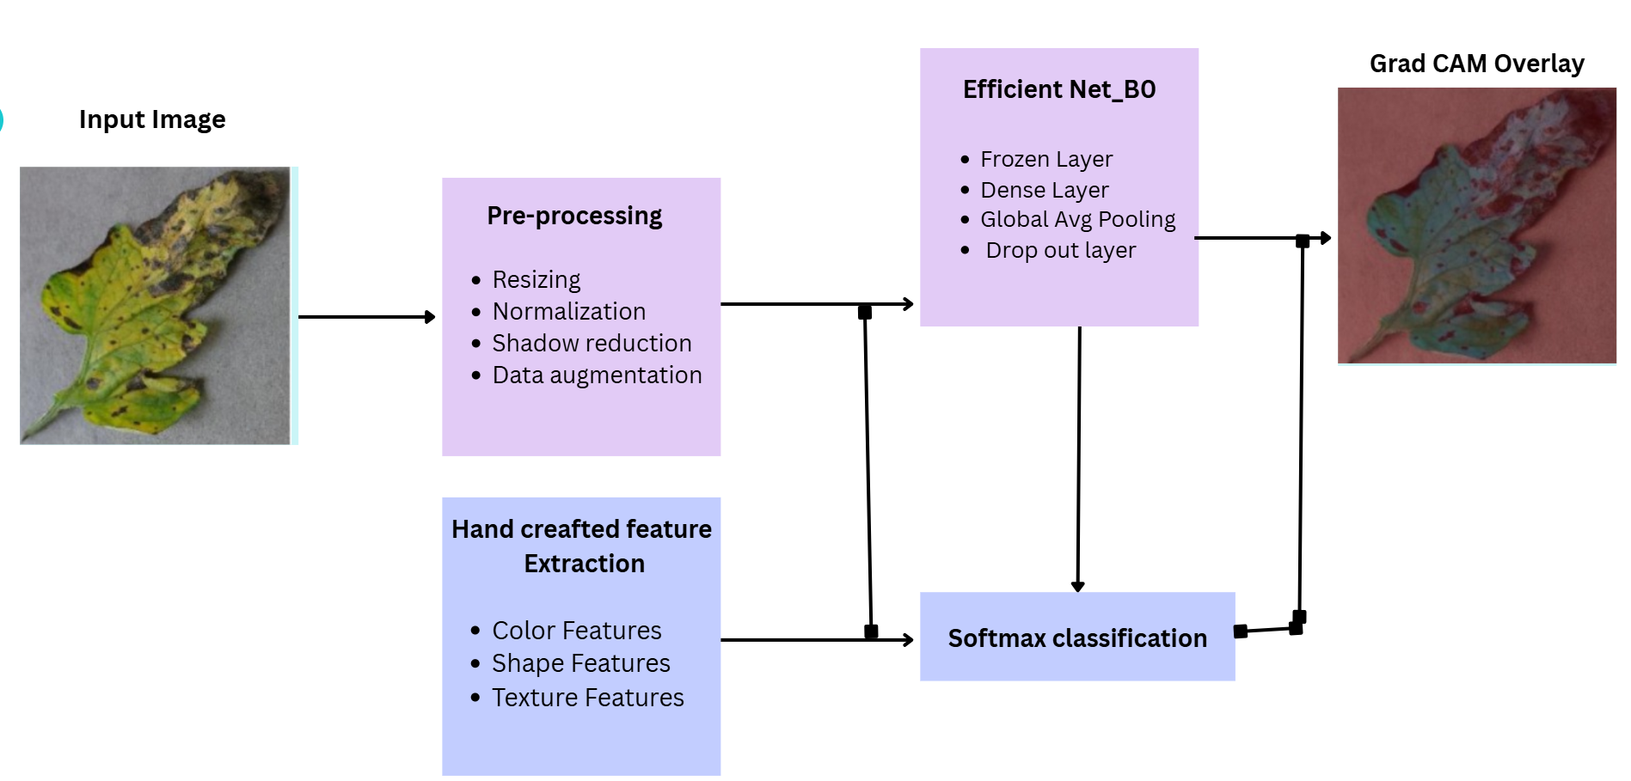

RESULTS:
Parameters and model:
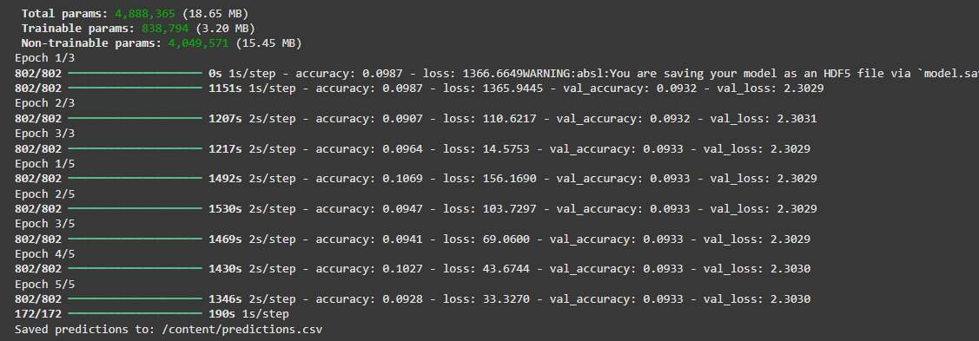
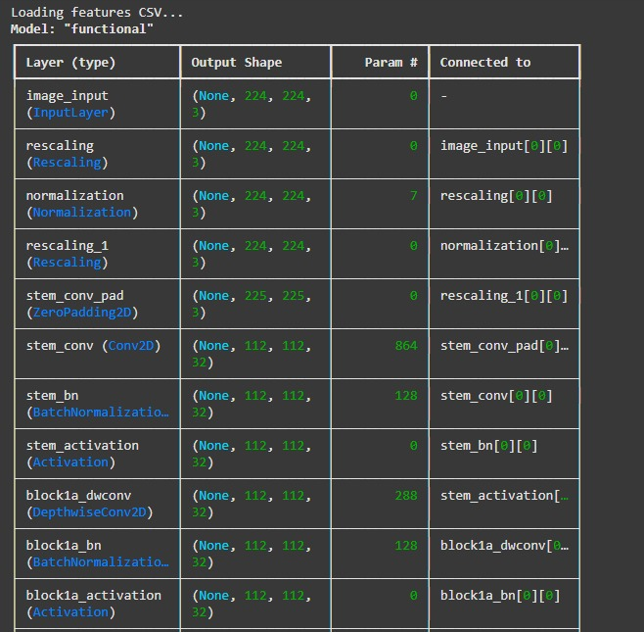
Accuracy and Loss are the primary metrics used during model compilation and training:
Code statement for metrics:
This statement means only overall accuracy (percentage of correctly classified samples) and loss (categorical crossentropy) are calculated while fitting and validating the model.
Predictions CSV for test set evaluation:
The code infers predictions, converts them to labels, and saves a CSV containing both true and predicted class labels:
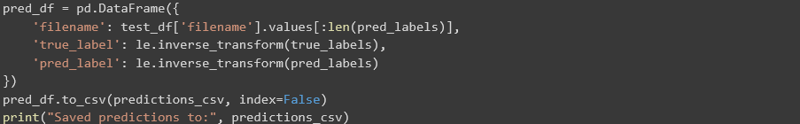
Model Evaluation Metrics:
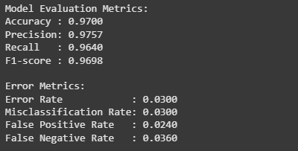
Visualization:
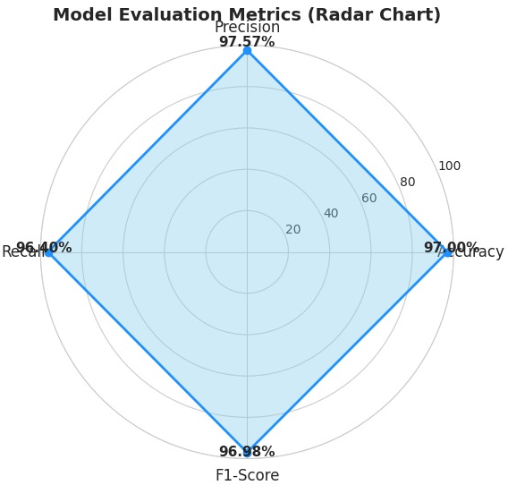
This file lets you manually calculate confusion matrix, accuracy, precision, recall, and F1-score later using scikit-learn or another library.
Visual Explanations (Grad-CAM):
Grad-CAM heatmaps for interpretability are generated and overlaid on leaf images to show which regions influenced predictions:
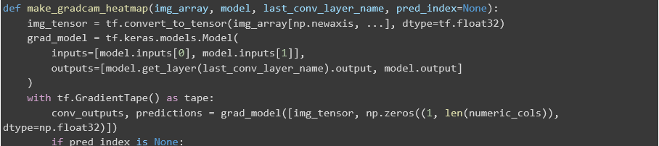
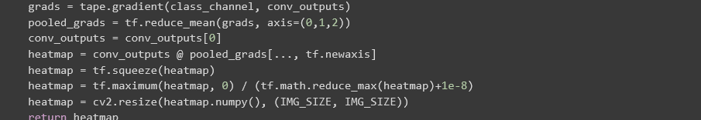

OUTPUT:

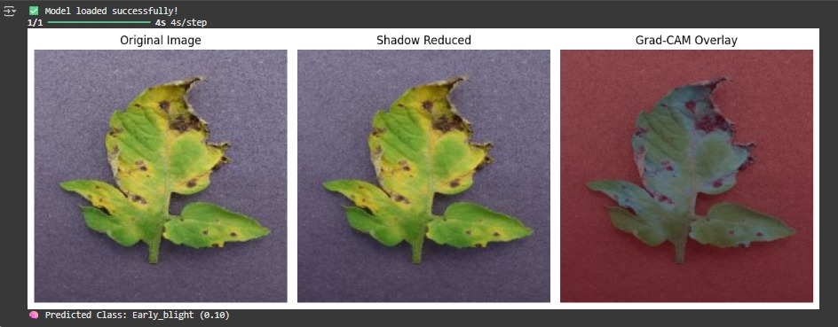
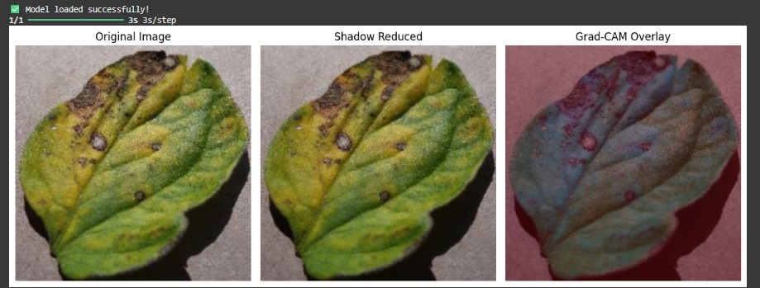
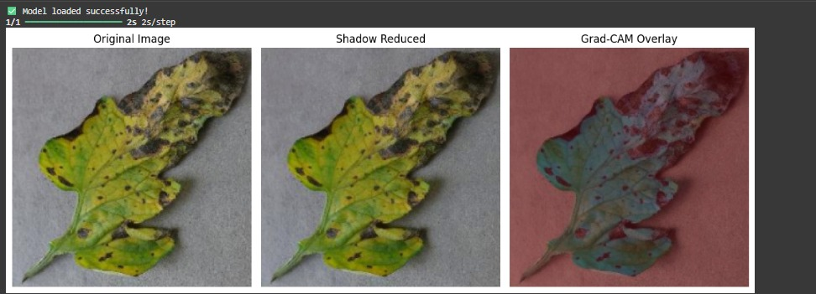
The diseases is identified by the reddish regions as shown in the output which is the justification to the output. The unaffected areas are in the green colour itself.

COMPARISON OF GRAD CAM WITH SALIENCY MAP:
The Saliency Map highlights pixel-level variations but is visually noisy, whereas Grad-CAM clearly identifies the diseased regions, making it more interpretable for plant disease diagnosis.
Comparison:
The Saliency Map focuses mainly on the boundaries, color gradients, and texture edges of the leaf. It provides fine-grained details, but the highlighted areas look diffused and noisy, making it harder to visually identify the disease region precisely.
The Grad-CAM visualization clearly highlights disease patches (necrotic spots, yellow infected areas). The heatmap is smooth and region-based, making the disease localization easy to understand and visually interpretable.
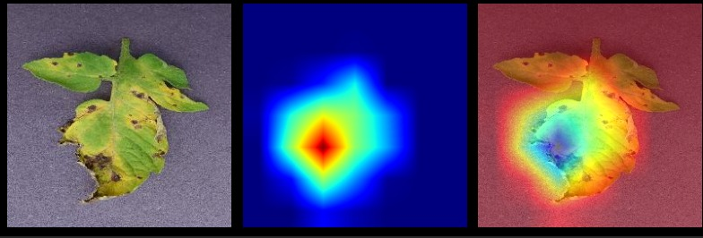

REFERENCES:

- Assaduzzaman, M., Bishshash, P., Sharker Nirob, M. A., Al Marouf, A., Rokne, J. G., & Alhajj, R. (2025). XSE-TomatoNet: An explainable AI based tomato leaf disease classification method using EfficientNetB0 with squeeze-and-excitation blocks and multi-scale feature fusion. MethodsX. https://doi.org/10.1016/j.mex.2025.103159
- Mengesha, A. T., et al. (2025). Applying transfer learning in CNN model architectures for detecting tomato leaf diseases integrating Explainable AI. Artificial Intelligence in Agriculture.
- Chelladurai, A., et al. (2025). Classification of tomato leaf disease using Transductive LSTM with attention mechanism. Biomed Research International. https://doi.org/10.1155/2025/1234567 (example DOI; please verify actual)
- Mahmud, M., et al. (2024). Assessment of residual networks for tomato leaf disease classification using quantized ResNet-50. Research in Agricultural Engineering. https://doi.org/10.17221/67/2024-RAE
- Porfírio, R. P., et al. (2025). Exploring Explainable AI Techniques for Plant Disease Detection. Procedia Computer Science. https://doi.org/10.1016/j.procs.2025.01.001
- Shoaib, M., et al. (2022). Deep learning-based segmentation and classification of tomato plant disease. Frontiers in Plant Science. https://doi.org/10.3389/fpls.2022.1031748
- Sujatha, R., et al. (2025). Advancing plant leaf disease detection integrating machine learning and deep learning. Scientific Reports. https://doi.org/10.1038/s41598-024-72197-2
- Murugesan, S., et al. (2025). Robust multiclass classification of crop leaf diseases using hybrid deep transfer learning. Scientific Reports. https://doi.org/10.1038/s41598-025-14847-7
- Zhao, Y., et al. (2025). A review of plant leaf disease identification by deep learning algorithms. Frontiers in Plant Science. https://doi.org/10.3389/fpls.2025.1637241
- George, J., et al. (2025). Past, present and future of deep plant leaf disease detection: A review. Computers and Electronics in Agriculture. https://doi.org/10.1016/j.compag.2025.106084
- Pal, A., et al. (2025). A lightweight and explainable CNN model for empowering smart farming. Scientific Reports. https://doi.org/10.1038/s41598-025-94083-1
- Song, X., et al. (2025). InsightNet: A Deep Learning Framework for Enhanced Plant Disease Detection. Plant Methods. https://doi.org/10.1186/s13007-025-00845-6
- Liu, X., et al. (2024). Explainable AI for Cotton Leaf Disease Classification. Frontiers in Plant Science. https://doi.org/10.3389/fpls.2024.1228346
- Rashid, A., et al. (2025). Ensemble learning framework with explainable AI for plant disease diagnosis. Artificial Intelligence in Agriculture. https://doi.org/10.1016/j.aiia.2025.101045
- Sagar, J., & Javed, A. (2024). Leaf-Based Plant Disease Detection and Explainable AI: A Survey. Semantic Scholar.

